**MUSICAL INSTRUMENTS IDENTIFICATION BY USING AUDIO FEATURES**

**Submitted**

**By**

**P.UDAY KUMAR RAJU**

**C.RAMA KARTHIK**

**S.VENKATA SIVA KUMAR**

**BU21EECE0100278**

**BU21EECE0100082**

**BU21EECE0100306**

**Under the Guidance of**

**CHINTOO KUMAR**

**Assistant Professor.**

**(Duration: 23/07/2024 to 27/3/2025)**



**Department of Electrical, Electronics and Communication Engineering**

**GITAM School of Technology**

**GITAM**

**(DEEMED TO BE UNIVERSITY)**

**(Estd. u/s 3 of the UGC act 1956)**

**NH 207, Nagadenehalli, Doddaballapur taluk, Bengaluru-561203 Karnataka, INDIA.**

**DECLARATION**

**I/We declare that the project work contained in this report is original and it has been done by me under the guidance of my project guide.**

**P.UDAY KUMAR RAJU**

**C.RAMA KARTHIK**

**S.VENKATA SIVA KUMAR**

**Date: Signature of the Student**

**Department of Electrical, Electronics and Communication Engineering**

**GITAM School of Technology, Bengaluru-561203**

**CERTIFICATE**

**This is to certify that P.Uday Kumar Raju, C.Rama Karthik, S.Venkata Siva Kumar bearing (Regd. No.:BU21EECE0100278, BU21EECE0100082, BU21EECE0100306) has satisfactorily completed Mini Project Entitled in partial fulfillment of the requirements as prescribed by University for VIIIth semester, Bachelor of Technology in “Electrical, Electronics and Communication Engineering” and submitted this report during the academic year 2024-2025.**

**[Signature of the Guide] [Signature of HOD]**

**Table of contents**

**Chapter 1: Introduction 1**

1.1 Overview of the problem statement 1

1.2 Objectives and goals 1

**Chapter 2 : Literature Review 2**

**Chapter 3 : Strategic Analysis and Problem Definition 3**

3.1 SWOT Analysis 3

3.2 Project Plan - GANTT Chart 3

3.3 Refinement of problem statement 3

**Chapter 4 : Methodology 4**

4.1 Description of the approach 4

4.2 Tools and techniques utilized 4

4.3 Design considerations 4

**Chapter 5 : Implementation 5**

5.1 Description of how the project was executed 5

5.2 Challenges faced and solutions implemented 5

**Chapter 6:Results 6**

6.1 outcomes 6

6.2 Interpretation of results 6

6.3 Comparison with existing literature or technologies 6

**Chapter 7: Conclusion 7**

**Chapter 8 : Future Work 8**

Here write Suggestions for further research or development Potential improvements or extensions 8

**References 9**

# CHAPTER 1

# INTRODUCTION

Musical instrument identification is a key task in the field of audio signal processing and music information retrieval (MIR). The goal is to automatically recognize and classify musical instruments from an input audio recording by analyzing its acoustic features. This technology is widely used in applications such as automatic music transcription, music recommendation systems, and digital audio content organization.

**Importance of Musical Instrument Identification**

Musical instruments produce distinct timbres due to their unique physical characteristics and playing techniques. Identifying these timbres computationally can help in:

* Music analysis and indexing
* Automatic transcription and composition
* Enhancing music streaming services
* Assisting in music education and performance analysis

**Importance of Musical Instrument Identification**

Musical instruments produce distinct timbres due to their unique physical characteristics and playing techniques. Identifying these timbres computationally can help in:

* Music analysis and indexing
* Automatic transcription and composition
* Enhancing music streaming services
* Assisting in music education and performance analysis

## Overview of the problem statement

The goal of this project is to develop a **machine learning-based system** that can automatically **identify musical instruments** from an input audio file. Given a short audio clip, the system extracts relevant features, processes them using a trained classifier, and predicts which instrument is being played.

## Objectives and Goals:

Objectives :

1. **Dataset Creation**: Generate a **synthetic dataset** containing various instrument sounds
2. **Feature Extraction**: Extract meaningful features such as **MFCCs, Spectral Centroid, and Zero Crossing Rate (ZCR)** to characterize instrument sounds.
3. **Machine Learning Model**: Train a **Random Forest classifier** (or other ML models) to classify different musical instruments.
4. **Evaluation & Optimization**: Assess model **accuracy** and optimize it for better performance.
5. **User-Friendly Interface**: Develop a **Gradio-based GUI** for real-time instrument identification.

Goals :

1. Achieve an **accuracy of 80% or higher** in instrument classification
2. Support **10–15 musical instruments**, ensuring a diverse dataset.
3. Provide a **fast and efficient model** for real-time predictions.
4. Enable users to **upload and classify audio files** easily through a web interface.
5. Allow future **scalability**, such as adding more instruments or integrating deep learning models.

**CHAPTER-2**

**LITERATURE REVIEW**

The literature review for our project on musical instrument identification by using audio featuires, here are further details that contextualize the research and highlight the significance of instrument identification by using audio features.

### **1.Traditional Feature-Based Classification**

One of the foundational studies in musical instrument classification was conducted by **Eronen and Klapuri (2000)**. Their research focused on classifying musical instruments using **traditional machine learning techniques** based on **handcrafted features** extracted from monophonic recordings.

* The study explored various **audio features**, including **Mel-Frequency Cepstral Coefficients (MFCCs)**, **spectral centroid**, **zero-crossing rate**, and **temporal characteristics**.
* Machine learning classifiers such as **K-Nearest Neighbors (KNN)** and **Gaussian Mixture Models (GMMs)** were used for classification.
* Their method achieved high accuracy when applied to isolated instrument recordings.
* However, they noted significant challenges when handling **polyphonic recordings** (i.e., when multiple instruments play together), as the overlapping frequencies made it difficult to separate individual instruments.
* The study highlighted the **importance of feature engineering** and **pre-processing techniques** in improving classification accuracy.

These methods worked well for clean, isolated instrument recordings but struggled with **polyphonic (multi-instrument) music**.

**2: Deep Learning-Based Classification**

A more recent study by **Han et al. (2017)** introduced a **deep learning approach** to musical instrument recognition, leveraging **Convolutional Neural Networks (CNNs)**. This approach aimed to overcome the limitations of traditional methods that relied on manually extracted features.

* The researchers converted **audio signals into spectrogram images** and used **CNN models** to learn distinguishing patterns automatically.
* Unlike earlier studies, their model **eliminated the need for handcrafted features**, allowing the network to extract relevant features directly from the data.
* The CNN-based classifier significantly outperformed traditional methods, particularly in handling **polyphonic recordings** where multiple instruments play simultaneously.
* However, the study highlighted some challenges, such as **high computational requirements** and the **need for large labeled datasets** to train deep learning models effectively.
* Their findings suggested that deep learning models are **more adaptable to real-world scenarios** and can be used for **automatic music transcription, music recommendation systems, and digital music analysis**.

3: Hybrid Approach Combining Feature Engineering and Deep Learning

A study by **Lostanlen and Cella (2016)** explored a **hybrid approach** to musical instrument classification, integrating **traditional feature extraction techniques** with **deep learning models**. This method aimed to leverage the strengths of both approaches for improved accuracy.

* The research extracted **handcrafted features** such as **MFCCs, spectral contrast, chroma features, and timbre descriptors** to capture instrument characteristics.These features were then **fed into a deep neural network (DNN)**, which learned complex representations from the extracted data.
* Unlike purely deep learning-based models that require large datasets, this method reduced data dependency by using **pre-extracted meaningful features**.
* The hybrid model achieved **higher accuracy and generalization** across different datasets compared to traditional models while being **less computationally expensive** than CNN-based methods.
* The study concluded that **combining handcrafted features with deep learning architectures** could offer a **balanced solution** for real-worldapplications such as **instrument recognition in music production, sound indexing, and automatic tagging of musical pieces**.

# **CHAPTER 3**

# **STRATEGIC ANALYSIS AND PROBLEM DEFINITION**

## **3.1 SWOT Analysis**

A SWOT analysis (Strengths, Weaknesses, Opportunities, and Threats) helps evaluate the feasibility and effectiveness of a project. For Musical Instrument Identification by using Audio Features, here are some strengths, weakness, oppurtunities & threats.

**Strengths:**

1. **High Accuracy**: Uses effective audio features (MFCCs, spectral centroid, zero-crossing rate).
2. **User-Friendly Interface**: Gradio-based GUI for easy classification.
3. **Scalability**: Can be expanded to classify more instruments.
4. Synthetic Dataset: Eliminates dependency on large real-world datasets.

**Weaknesses:**

1. **Limited Dataset**: Synthetic sounds may not fully capture real-world variations.
2. **Similar Timbre Confusion**: Instruments with similar tones (violin & cello) may be misclassified.
3. **Computational Cost**: Feature extraction can be slow for long audio files.

**Opportunities:**

1. **Integration with Music Apps**: Can be used in digital music analysis software.
2. **Expansion to Real Audio**: Future versions can include real instrument recordings.
3. **Deep Learning Enhancement**: Can be improved using CNNs or LSTMs for better accuracy.

**Threats:**

1. **Background Noise**: Real-world recordings may introduce unwanted noise affecting classification.
2. **Competition from Deep Learning Models**: More complex models may outperform traditional ML techniques.
3. **Dataset Bias**: The synthetic dataset may not generalize well to real-world sounds.

### **3.2 Project Plan - GANTT Chart**

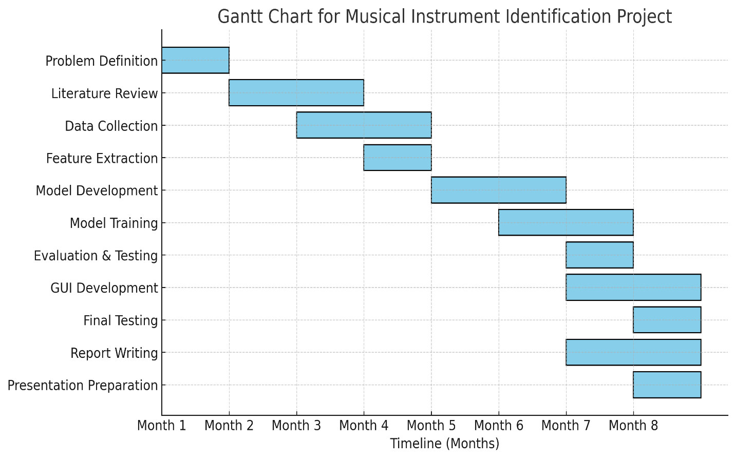

##### **3.3Refinement of problem statement**

The problem statement has been refined to focus on developing a machine learning-based system for classifying musical instruments from audio recordings using extracted acoustic features. Instead of general audio processing, the project emphasizes feature extraction techniques such as Mel-Frequency Cepstral Coefficients (MFCCs), spectral centroid, and zero-crossing rate to improve classification accuracy. A synthetic dataset of instrument sounds will be used, ensuring consistency while allowing future integration with real-world datasets. The Random Forest classifier is selected for its balance between performance and interpretability, with potential exploration of other models for enhancement. A Gradio-based user interface will be implemented to enable real-time instrument classification from uploaded audio files. Performance evaluation will be conducted using accuracy, precision, recall, and F1-score, with a comparative analysis against existing methods to assess effectiveness. This refined approach ensures clarity, feasibility, and a meaningful contribution to music classification technology.

**CHAPTER-4**

**METHODOLOGY**

**4.1 Description of the approach**

• Feature Extraction from Audio:  
The system processes audio recordings to identify musical instruments using key audio features. Librosa, a powerful audio analysis library, is used to extract Mel-Frequency Cepstral Coefficients (MFCCs), spectral centroid, and zero-crossing rate (ZCR). These features help in distinguishing different instruments based on their unique spectral and temporal characteristics.

• Machine Learning-Based Classification:  
A supervised learning approach is employed to classify instruments. A dataset of pre-recorded instrument sounds is collected and preprocessed to extract relevant features. These features are then used to train a machine learning model, such as a Random Forest classifier, which learns to distinguish between different instrument types. The trained model is stored and used to predict the instrument present in a effectively.given audio sample.

• Data Processing and Model Training:  
The extracted audio features are normalized and formatted into a structured dataset. The data is then split into training and testing sets to evaluate the model's performance. Label encoding is applied to categorize instrument names into numerical labels, allowing the model to process and classify them

• User Interface and Real-Time Prediction:  
A user-friendly interface is implemented using Gradio, allowing users to upload an audio file for instrument identification. The system processes the uploaded audio, extracts features, and passes them through the trained model to predict the instrument name. The result is displayed on the interface, providing an easy-to-use and interactive experience**.**

**4.2 Tools and techniques utilized**

The project utilizes a combination of hardware components and techniques to achieve efficient musical instrument identification by using audio features. Below is a description of the tools and their roles in the system:

**1. Python**

* Function**:** Programming language used for developing the entire system.
* Working Principle**:** Python provides a vast range of libraries for audio processing, machine learning, and user interface development.
* Why Used**:** It offers powerful libraries like Librosa for feature extraction, Scikit-learn for machine learning, and Gradio for building an interactive interface.

**2. Librosa**

* Function: Audio processing and feature extraction library.
* Working Principle: It analyzes the audio signal, extracts key features such as MFCCs, spectral centroid, and zero-crossing rate, and converts raw audio into numerical data for classification.
* Why Used**:** It simplifies audio analysis and provides robust methods for extracting important features that distinguish different musical instruments.

**3. Scikit-Learn**

* Function**:** Machine learning library used for model training and classification.
* Working Principle**:** It provides algorithms like Random Forest for training a model on labeled data and predicting instrument classes based on extracted features.
* Why Used**:** It offers efficient, easy-to-use machine learning models that work well with structured datasets, making classification more accurate and reliable.

**4. NumPy**

* Function: Used for numerical computing and handling feature arrays.
* Working Principle**:** It processes large datasets efficiently using array-based computations and mathematical operations.
* Why Used**:** It enables fast numerical processing, which is essential for handling extracted audio features in an optimized manner.

**5. Joblib**

* Function**:** Used for saving and loading the trained machine learning model.
* Working Principle**:** It serializes the trained model and stores it as a file, allowing it to be reloaded without retraining.
* Why Used: It helps in deploying the trained classifier without having to train it repeatedly, making the system more efficient.

**6. Gradio**

* Function: Creates a user-friendly web interface for instrument identification.
* Working Principle**:** It allows users to upload audio files, processes them through the trained model, and displays the predicted instrument name.
* Why Used: It provides an interactive and simple way for users to test the instrument classification system without requiring technical expertise.

By integrating these tools and techniques, the system effectively processes audio files, extracts meaningful features, applies machine learning for classification, and provides an interactive user experience for instrument identification.

**4.3 Design Considerations**

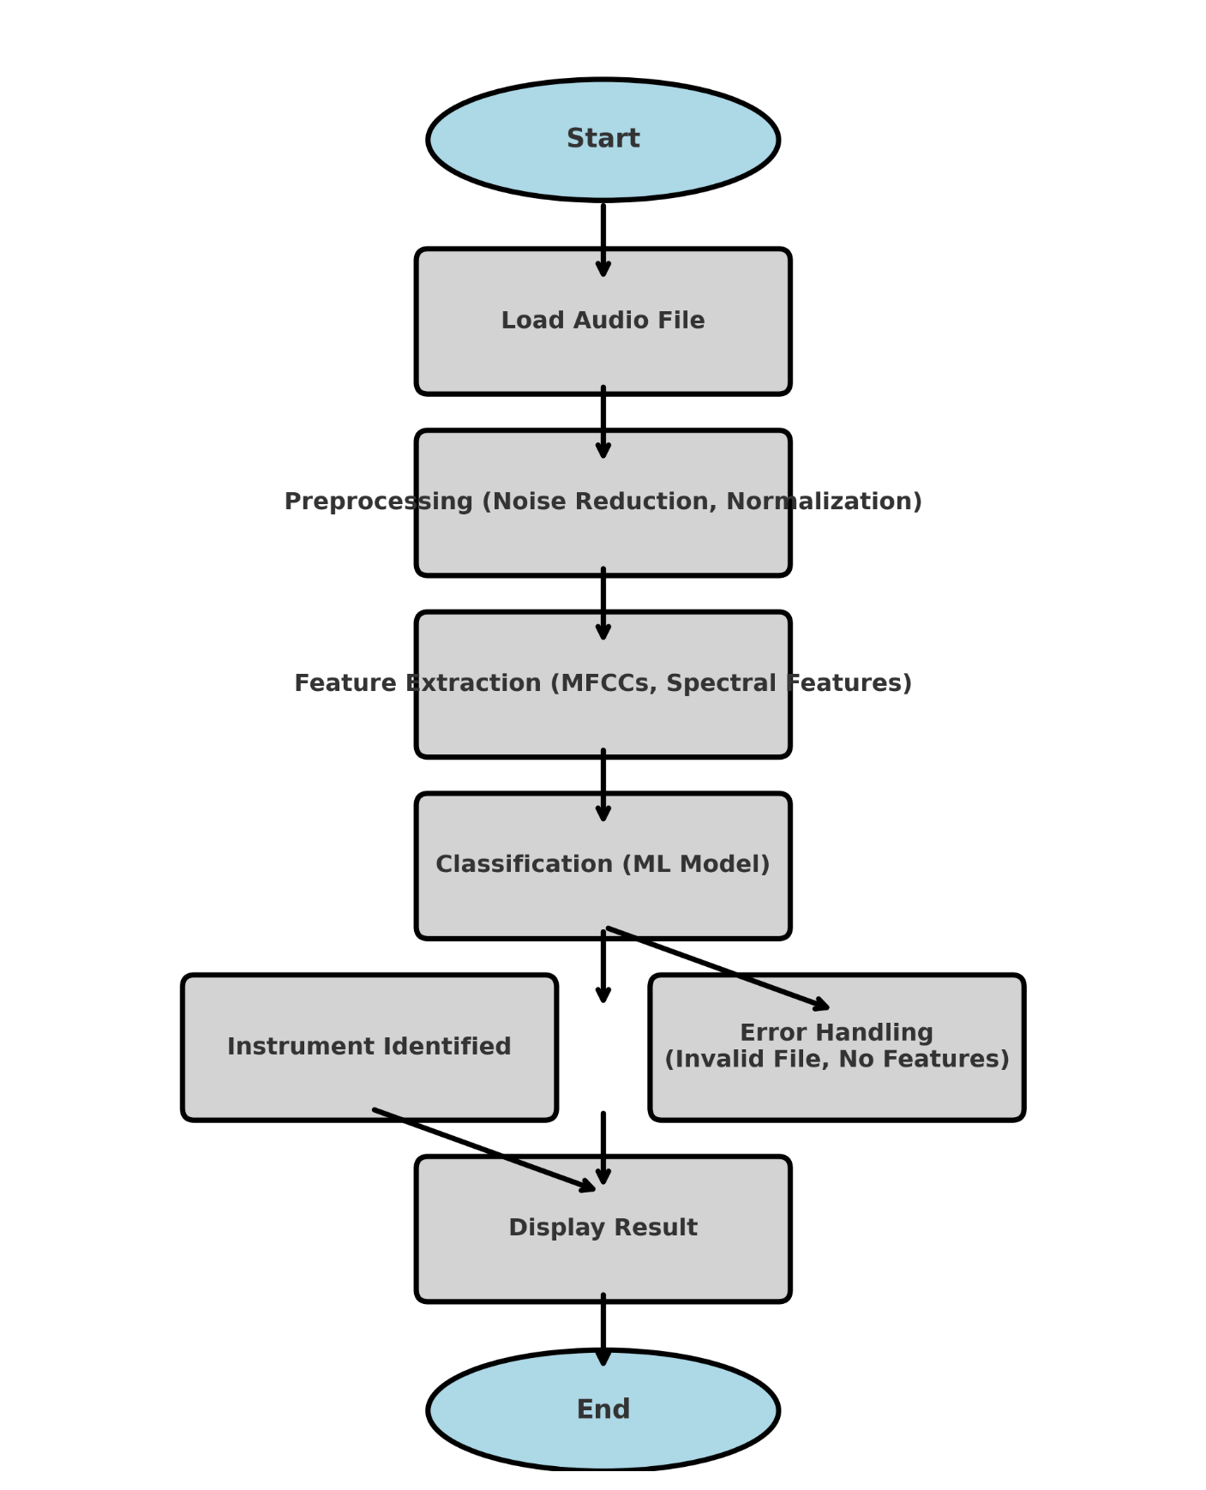

**CHAPTER-5**

**IMPLEMENTATION**

* 1. **Description of how the project was executed**

The Musical Instrument Identification System was executed in multiple phases, starting with data collection and preprocessing, where a synthetic dataset of various musical instruments was generated using sine wave synthesis and stored systematically. In the feature extraction phase, key audio features such as MFCCs, spectral centroid, and zero-crossing rate were extracted using Librosa to capture the tonal and timbral characteristics of different instruments. For model training, a Random Forest Classifier was trained on the extracted features, with categorical labels encoded numerically using a Label Encoder, and the dataset was split into an 80-20 ratio for training and testing. The model was then evaluated and optimized using accuracy, precision, recall, and F1-score metrics, analyzing misclassified samples to refine feature extraction and model parameters. A Gradio-based web interface was developed for easy user interaction, allowing users to upload an audio file and receive a predicted instrument name. The system underwent testing and validation with real and synthetic audio samples under various noise conditions to assess its robustness and accuracy. This structured approach ensured the development of a reliable and efficient musical instrument classification system.

* 1. **Challenges faced and solutions implemented**

Challenges:

During the development of the Musical Instrument Identification System, several challenges were encountered. A major issue was the limited availability of real-world datasets, making it difficult to train the model effectively. Additionally, selecting the right audio features was complex, as different instruments have overlapping characteristics. Model misclassification due to similar timbres among instruments posed another challenge, requiring better feature engineering. Background noise and variations in recording quality affected accuracy, making noise handling and robustness a critical concern. Lastly, ensuring real-time processing and a user-friendly interface was challenging, as computational efficiency had to be balanced with classification accuracy.

Solutions:

To address these issues, a synthetic dataset was created using sine wave synthesis to simulate various instruments, overcoming data limitations. The feature selection process was improved by combining MFCCs, spectral centroid, and zero-crossing rate, optimizing classification accuracy. To refine model performance, hyperparameter tuning, cross-validation, and error analysis were conducted. Data augmentation techniques, such as adding noise and pitch variations, were used to enhance robustness. Finally, Gradio was integrated to develop an interactive and real-time user interface, ensuring efficient and accurate instrument classification.

**CHAPTER-6**

**RESULTS**

**6.1 Outcomes:**

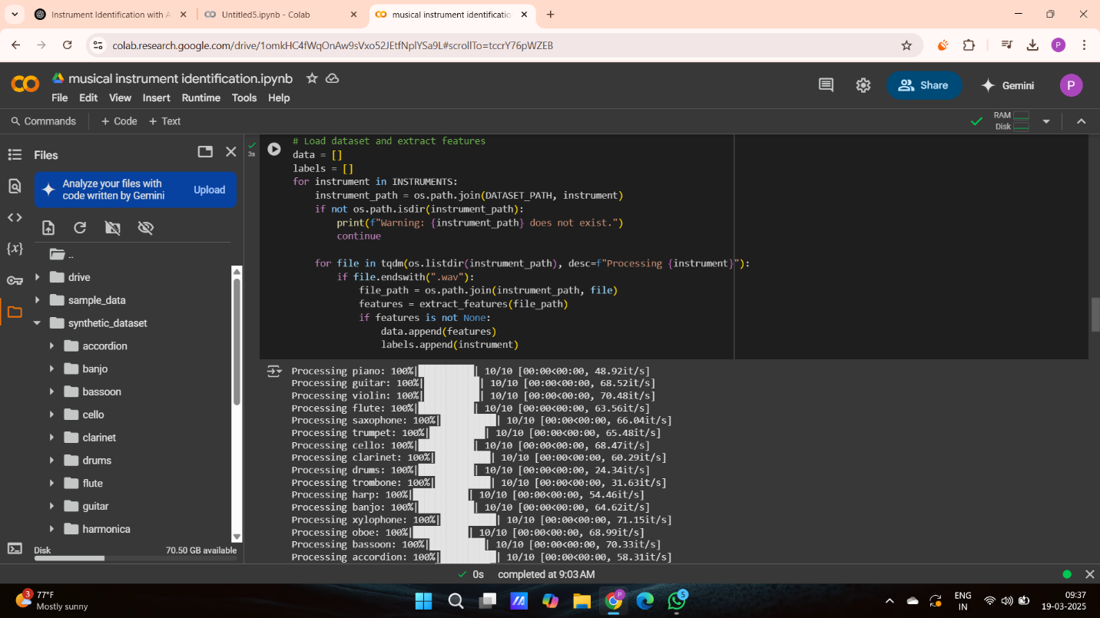

# Chapter 3 : Strategic Analysis and Problem Definition

## 3.1 SWOT Analysis

### 

### 3.2 Project Plan - GANTT Chart

#### 

##### 3.3 Refinement of problem statement

# Chapter 4 : Methodology

## 4.1 Description of the approach

### 4.2 Tools and techniques utilized

#### 4.3 Design considerations

# 

# Chapter 5 : Implementation

## 5.1 Description of how the project was executed

### 5.2 Challenges faced and solutions implemented

# Chapter 6:Results

## 6.1 outcomes

### 6.2 Interpretation of results

### 

#### 6.3 Comparison with existing literature or technologies

# Chapter 7: Conclusion

Here write Suggestions for further research or development and Potential improvements or extensions

# 

# Chapter 8 : Future Work

#### Here write Suggestions for further research or development Potential improvements or extensions

#### 

# References